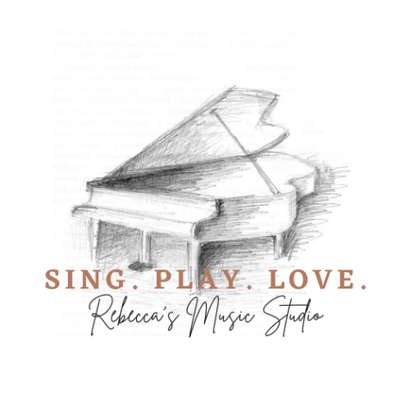
STUDIO POLICY 2022/2023

TEACHING APPROACH:
Students learn proper practice habits on a weekly basis, and are expected to bring a basic notebook to lessons, and follow their practice guidelines during the week. I also incorporate music theory into lessons.

I use many mixtures of methods and resources – depending on age and skill level. For piano, I typically use "method" books for beginners, then we branch out after the fundamentals are well-rooted. Curriculum and repertoire selection are based on the student’s individual needs and interests.

Musical style preference and personal goals are important. So be sure to share any dreams or specific goals with me! Do you want to play in the Wichita Youth Symphony program, play keyboard in a worship band, or maybe focus on Celtic fiddle? These are just a few examples.

TUTION FEES/ENROLLMENT:

Weekly 1/2 hour private lessons are $80/month ($100 for 5 week months). 1 hour lessons are $160/month ($200 for 5 week months). I offer private lessons for piano, violin, viola, cello, & voice.

Fees are due at the first lesson of the month. If fees fall behind, a $10 late fee may be applied after the 2nd lesson of the month. After 3 weeks, lessons may be suspended until fees are caught up.

REGISTRATION:

There is an initial, non-refundable registration fee of $25 for each student's lesson slot. ($40 max per family)

PAYMENT:

Forms of payment accepted include cash, check, Google Pay, Venmo (@RebeccaErin), or Paypal (Rebeccaerin84@gmail.com)

LESSON TIME SLOTS:

Time slots/openings are updated periodically on my website. Or you may ask about a particular time. Students are expected to consistently attend lessons at their regular scheduled time.

PAYMENT FOR MISSED LESSONS:

I do not wave or adjust monthly fees for missed, skipped, or cancelled lessons. I only offer make-up lessons.

MAKE-UP LESSONS:

24 hours advance cancellation notice is required in order to receive a make-up lesson. If no communication is received prior to a missed lesson, there will be no make-up lesson offered. For cancellations on my end, I will ensure there are make-up lessons. Virtual lessons are also an option, particularly if there is sickness in the household, etc.

I only offer one make-up lesson per month for lessons cancelled or rescheduled by students, and full month’s fees will be due regardless of attendance.

EARLY/LATE ARRIVAL:

If you arrive early at my home teaching location, please wait to come in until your scheduled lesson time. If students are late to lessons, I will typically still need to end at the normal time.

GUM:

I don’t allow chewing gum during lessons or performances.

HOLIDAYS:

I do not take breaks except for Thanksgiving week and Christmas break. Spring Break week is also optional. If students need to reschedule due to various trips or holiday celebrations, please notify me in advance so we can reschedule a make-up time.

SUMMER:

Lesson enrollment is year-round, and continues during the summer. Daytime slots are preferred in the summer, if possible. But regular after work hours will remain available as well. Scheduling can become tricky when the new school year starts in August, so be sure to plan ahead!

BREAKS & LESSON TERMINATION:

Notice is required by the 10th of the month in order to cancel lesson enrollment for the following month, or to take a break from lessons. Otherwise, student attendance is optional, but tuition fees will still be charged for the following month. There is a $25 registration fee when re-starting. ($40 max per family) Lesson slots are not reserved/guaranteed without full monthly payment. If slots are full, students can be placed on the waiting list.

RECITALS:

We typically have 2 studio recitals per year. All students are expected to participate, but may opt out if necessary. Students and parents will be informed of these in advance. Friends and family are invited to attend, and each student/family will be asked to bring a snack or refreshment to share afterwards. Video and pictures are welcome. Pics and video taken by me may be posted on social media – so please let me know in advance if you are not comfortable with this.

REQUIRED MATERIALS:
- Notebook (for weekly assignments & practice instructions)
- Lesson books
- Instrument

~ For Piano: preferably a full size 88-key keyboard, electric or acoustic

~Strings: applicable size instrument (½, ¾, full size, etc.)
- Metronome
- FOR STRINGS - tuner/rosin/shoulder rest

PRACTICE:

Students are expected to practice every day, if possible, following the notes in their lesson notebook. Parents will need to supervise/assist younger students. Recommended practice times are:
- 10-15 minutes for ages 4 - 6
- 15-20 minutes for ages 7 - 12
- 30 minutes for older students.

Please let me know if you have concerns or questions. I am here to help you meet your goals, and appreciate your feedback!

Blessings, Rebecca

